# Project

@babuilyas/procheck.sap.middleware

## Purpose

The document is prepared to show understanding of the project and the scope identified together with the Procheck developer team and business analyst.

## Project Description

Procheck wants to deploy their proprietary plant analytics solution for a prospect client’s plant. The solution will not only provide equipment analytics but also react to events (such as breakdown, tear-down, speed) and will push some data(1) to client proprietary software(2) using BAPI (3).

1. PM Notification
2. SAP S4/HANA (release 1809)
3. BAPI is also called WebRFC in javascript

## Project Details (Citation needed)

The Procheck system has information of all equipment installed on the client side. An IoT has been installed on all equipment. IoT is connected to the Procheck cloud solution via the internet and sends equipment status related information regularly.

The cloud solution provides analytics and computes OEE etc and also reacts to the status of equipment based on defined criteria and generates events such as breakdown, malfunction, etc. These events are synchronously/asynchronously reported to the client in their system via notification.

## Project Scope (Costed)

We had finalized the scope as followed:

1. Development and Testing of SAP middleware Node Module
   1. 1 customer BAPIs will be wrapped with a lean function signature which will be usable as normal functional optional callbacks and promise feature
   2. 1 RFC PING BAPI will be wrapped for connection and latency test
   3. Documentation for the module features
2. Compiled source code will be delivered to be included in client project libraries
3. Deployment and Troubleshooting of middleware module
   1. Windows, Linux environments
4. Support and Revisions of code base until agreed consultation duration
5. Response Time will be 1-2 hours
6. Additional Services : My SAP expertise will be value addition in your corp profile
7. Additional Services : My SAP R&D servers will be available for the team and project

## Component Diagram

## 

## R&D Roles and Components

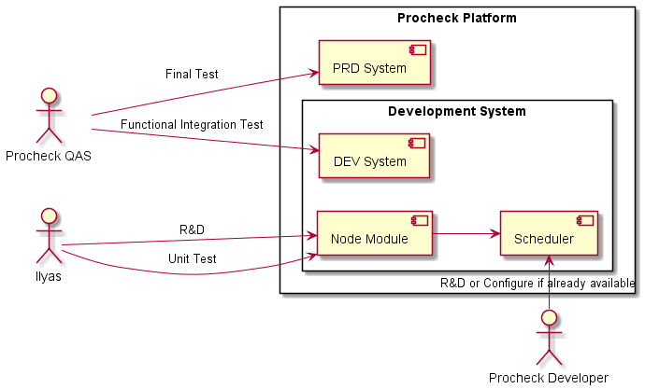

## Data flow Diagram for Notification API

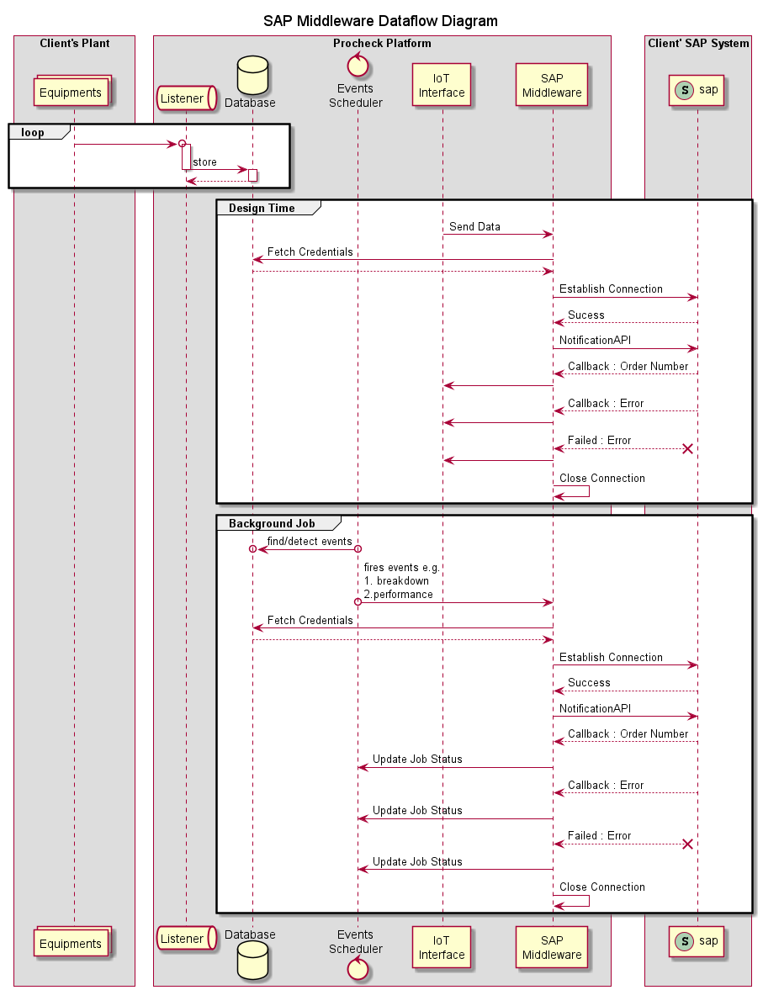

## 

## Project Cost

| Consultation Duration | Cost | Daily / Weekly Commitment |
| --- | --- | --- |
| 1 month  (from commencement of contract) | 75’000/- | 2 / 10 hours |